Core module 1- Practical assessment

Activity 1

Aim: Execute the flowing Linux commands: touch, echo, clear, ls, dir, mkdir, cat, rmdir, rm, cp, mv, head, tail, wc, sort.

# Requirements:

* Linux operating system
* Terminal

# Step 1: Go to the Linux operating system, open the terminal and follow the cmd.

**touch-**

**input:**

## **touch p1.txt**

Touch cmd use to create a blank txt file.

**Output:**

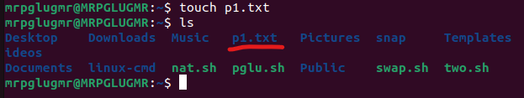

**echo-**

**input:**

**echo hi how are you**

**this cmd used for print some this**

**Output:**

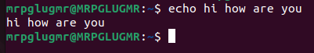

**clear-**

**input:**

**clear**

**use to clean the terminal (recants cmd)**

**Output:**

**Before**

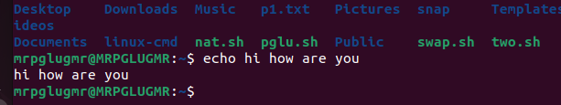

**After**





**ls-**

**input:**

**ls**

**ls use for list the all file.**

**Output:**

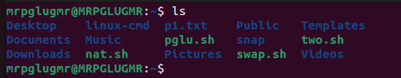

**dir-**

**input:**

**dir**

**show the all directory**

**Output:**

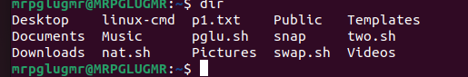

**mkdir-**

**input:**

**mkdir p2.txt**

**mkdir cmd use fro creating a new directory file.**

**Output:**

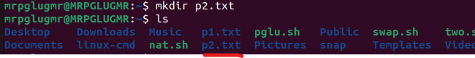

**cat-**

**input:**

**cat> p3.txt**

**cat cmd use for create a new txt file with contain.**

**Output:**

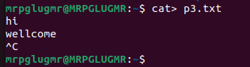

**input:**

**cat p3.txt**

**use to shoe what in side.**

**Output:**

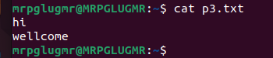

**rmdir-**

**input:**

**rmdir p2.txt**

**we are creating a directory p2.txt know we are removing.**

**Output:**

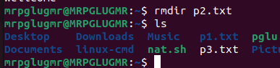

**rm-**

**input:**

**rm p3.txt**

**this cmd used to remove a txt file.**

**Output:**

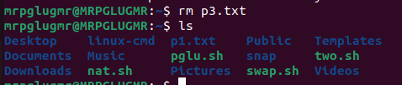

**cp-**

**input:**

**cp p1.txt p2.txt**

**we are creating two files p1.txt and p2.txt. here p1 have a data but p2 don’t have any data know we are copy the data to p2.txt file.**

**Output:**

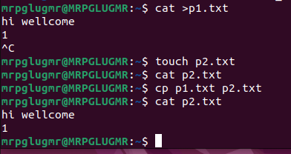

**mv-**

**input:**

**mv p1.txt p3.txt**

**know we are creating a txt file and move the p1.txt data to p3.txt**

**Output:**

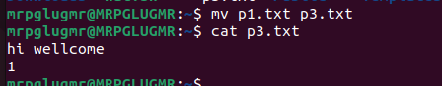

**head-**

**input:**

**head pglu.txt**

**head show the top 10 lines.**

**Output:**

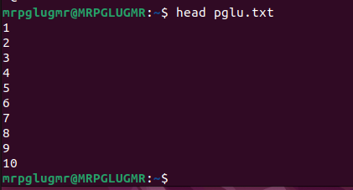

**tail-**

**input:**

**tail pglu.txt**

**tail show the last 10 line.**

**Output:**

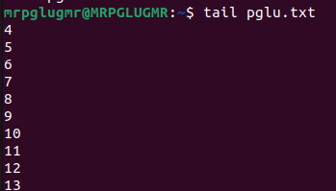

**wc-**

**input:**

**wc pglu.txt**

**wc use to count the no of words.**

**Output:**



**sort-**

**input:**

**sort mr.txt**

**sort cmd use for arranging the data by (A-Z).**

**Output:**

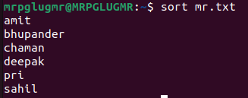

**input:**

**sort -r mr.txt**

**used to (Z-A)**

**Output:**

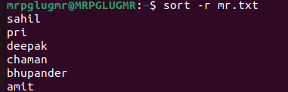

Activity 2

Aim: Configure wired and wireless network

# Requirements:

* Window operating system
* Cisco software
* 1 router
* 1 switch
* 2 pc
* 1 laptop
* 1 smart phone
* Ap-pt (Access point-pt)
* Straight through

Step 1: Go to the Cisco and take 1 router, 1 switch, 2 pc, 1 laptop, 1 smart phone and Ap-pt Wireless device.

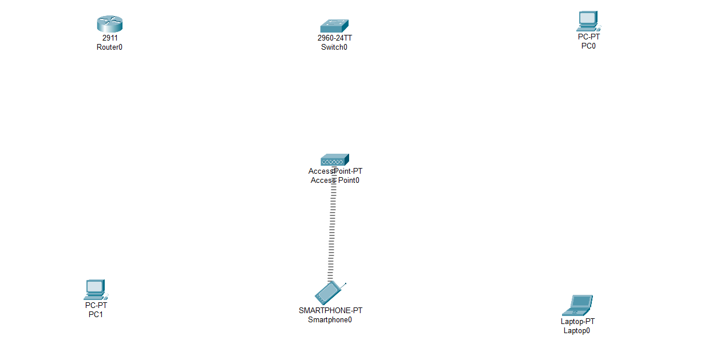

Step 2: Do connection with the help of straight through as follow.

* Router to Switch
* Switch to pc
* Switch to Ap-Pt

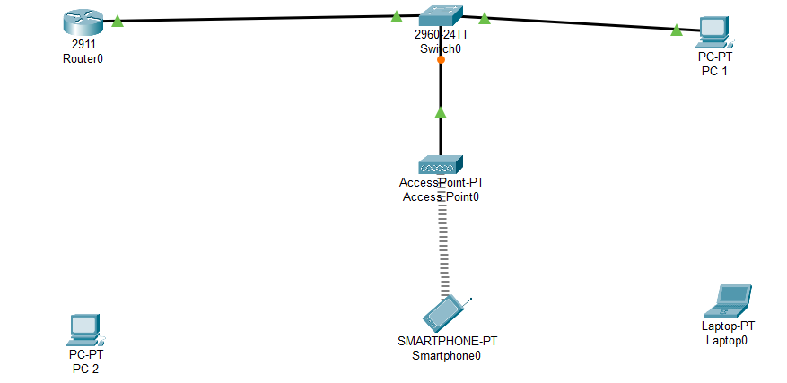

Step 3: Go to the desktop then go to the ip conf. and give the ip address as follow.

Gateway 10.0.0.1

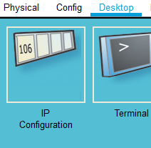

* Router—10.0.0.1 (gig0/0)

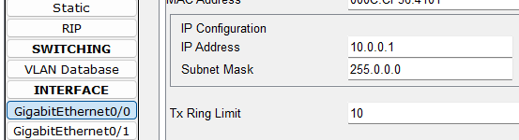

* Pc 1 -- 10.0.0.2

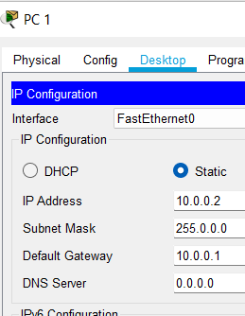

* Pc 2 -- 10.0.0.3

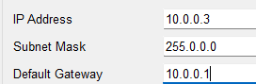

* Laptop – 10.0.0.4

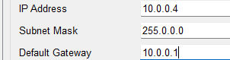

* Smart phone – 10.0.0.5

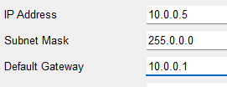

Step 4: know go to the pc 2 and laptop physical.

Then turn off the both machine and change the lan connector to WMP300N.

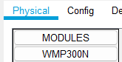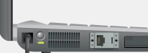

WMP300N

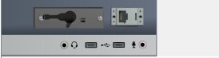

Know turn on the pc and laptop.

Step 5: Know go to the Ap-pt wireless. Then go to the config.

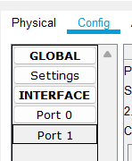

Step 6: go to the port 1 and give the SSID name with the wep key.

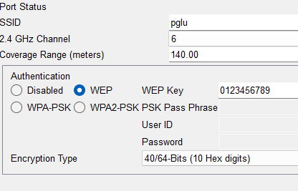

Step 7: Follow these points into the wireless device. ( pc 2, smartphone and laptop)

* Go to the desktop then go to the pc Wireless

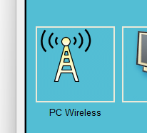

* Then go to the connect and refresh here you can see the ssid wireless network pglu just click on.

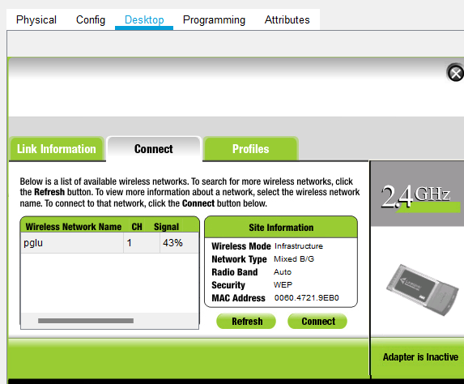

* Then click on connect and fill the key 0123456789 know you are connected to the wirelessly.

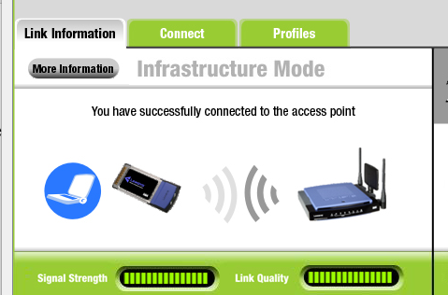

Step 8: know we are connect to wire and wireless.

Activity 3

Aim: Create a simulation for FTP service.

# Requirements:

* Window operating system
* Cisco software
* 2 router
* 2 switch
* 3 pc
* 1 Server
* Cross over cable
* Straight through cable

Step 1: Go to the Cisco and take 2 router, 2 switch, 3 pc, 1 Server, cross over and straight through cables.

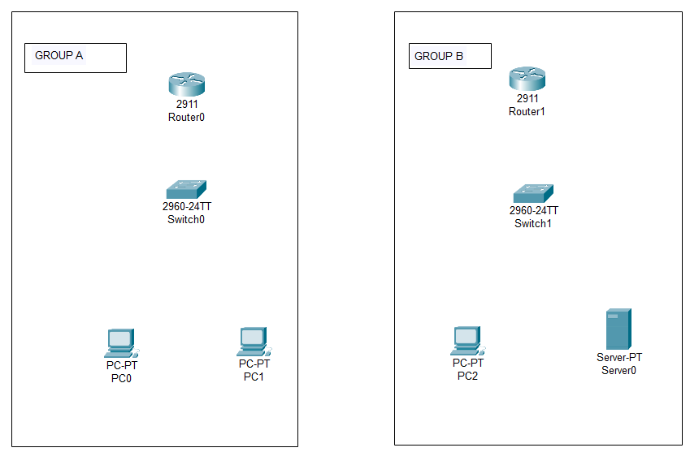

Step 2: Do connection with the help of straight through into the group a and group b and connect the both router with cross over cable.

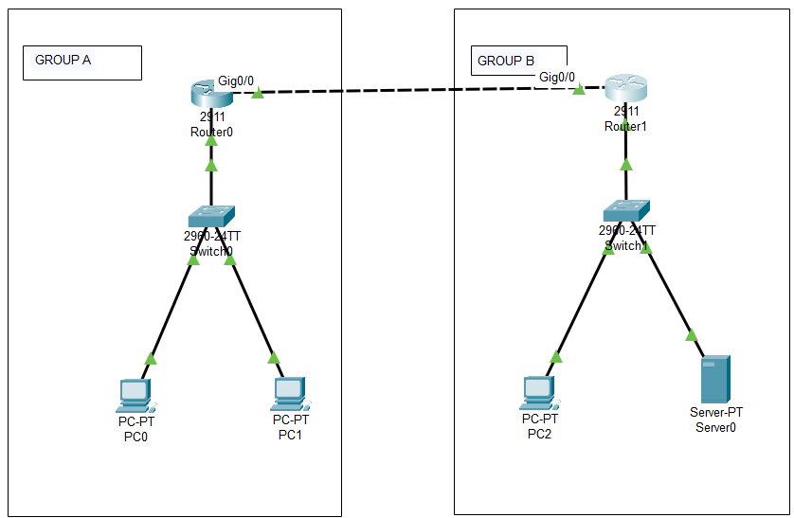

Step 3: Click on router then go to the config then give the ip as follow

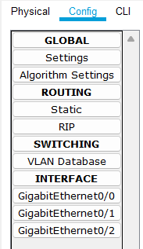

GROUP A

* Router—10.0.0.1 (gig0/1)

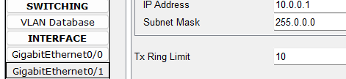

* Router--- 30.0.0.1 (gig0/0)

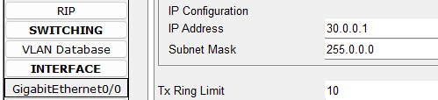

GROUP B

* Router – 20.0.0.1 (gig0/2)

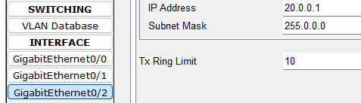

* Router – 30.0.0.2 (gig0/0)

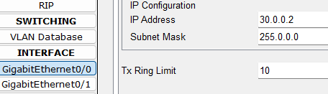

Step 4: go to the desktop then ip configuration after it give the ip as follow into the both group. Also give the server ip.

* Pc 0 – 10.0.0.2 (gateway 10.0.0.1) (server 20.0.0.3)
* 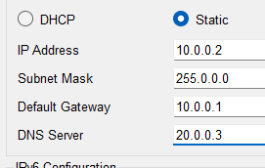
* Pc 1 – 10.0.0.3 (gateway 10.0.0.1) (server 20.0.0.3)
* Pc 2 – 20.0.0.2 (gateway 20.0.0.1) (server 20.0.0.3)
* Server – 20.0.0.3 (gateway 20.0.0.1) (server 20.0.0.3)

Step 5: do the RIP into the both routers.

GROUP A

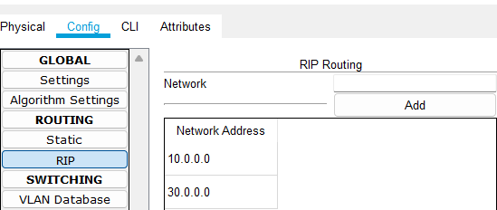

GROUP B

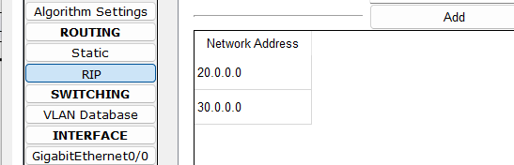

Step 6: Know go to the server then go to the services. Then go to the FTP.

Give the username, password and all rights then clivk on add.

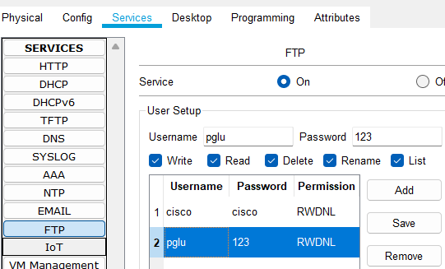

Step 7: Go to the pc 1 and click on the txt editor create a txt file.

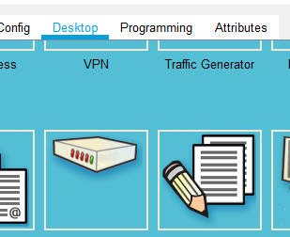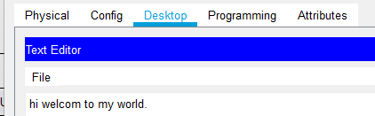

Step 8: Know go to the command prompt and follow the cmd.

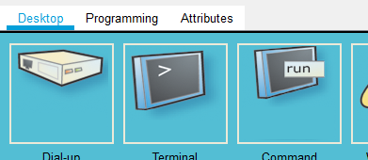

* Dir (show the available file)

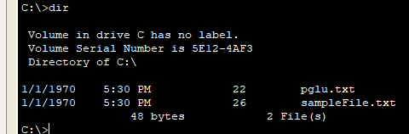

* ftp (access the server)

ftp 20.0.0.3 (20.0.0.3 is server ip)

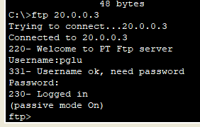

* Put (upload the file on server)

put pglu.txt

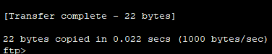

Step 9: Go to the pc 2 then go to the command prompt type as follow cmd.

* ftp

ftp 20.0.0.3 (20.0.0.3 is server ip)

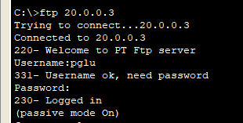

* get

get pglu.txt (get used for download a file and here pglu.txt is file)

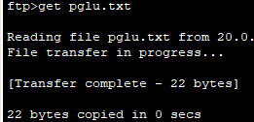

* dir (show the available file)

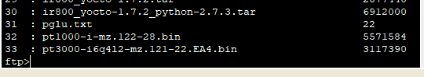

Here we are complete FTP services.